**System Design Specification**

**for**

**<**BYP online shopping system**>**

**Version 1.0 approved**

**Prepared by <Hissah, Nourah>**

**<organization>**

**<date created>**

**Table of Contents**

**Table of Contents ii**

**Revision History ii**

**1.** **Introduction 1**

1.1 Purpose 1

1.2 System Overview 1

1.3 Roles and Responsibilities 2

**2.** **Overall System Design 2**

2.1 Design Constraints 2

2.2 System Architecture 3

2.3 Database Design 3-4

2.4 Hardware and Software Design 5-7

2.5 Graphical User Interface Design 8-12

2.6 System Quality Attributes 13

**Appendix A: Glossary 13**

**Appendix B: Detailed Analysis Models 14**

**Appendix C: Issues List (If Any) 14**

# **Introduction**

## **Purpose**

*This is a software requirement specification for an online shopping system. This store is designed to allow the customers to be their personal shoppers to perform the process of buying completed outfits easily over the internet. This document will cover all requirements and functions of the shopping online system.*

## **System Overview**

*Designing the system is a very important step which helps the developer to understand the system for the implementation. The main goal of the system is to enable the shop owner of the BYP shop to sell all products that are related with fashion with complete outfit. It will be used by a customer who is interested to be different and have a unique outfit as what he/she likes . In our system we have only one available payment method which is credit card. In addition, it requires a database to allow the administrator to manage the overall system and customers’ orders. The database will be created by My sql and the system will be implemented by NetBeans IDE 8.2 program. In terms of hardware, this system will require the devices that provide the Internet such as mobile phone, laptop, tablet, and desktop.*

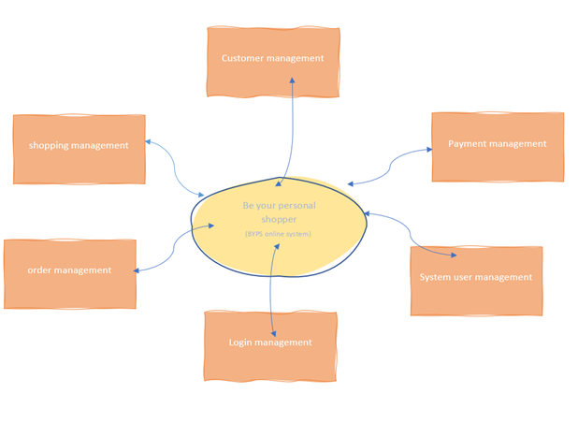

*Figure1*

## **Roles and Responsibilities**

| *name* | *responsibilities* |
| --- | --- |
| *Hissah alwasifer* | *database design+system architecture* |
| *Norah almosened* | *software design+system architecture* |

# **Overall System Design**

## **Design Constraints**

BYP online shopping system doesn't require any design constraints.

## **System Architecture**

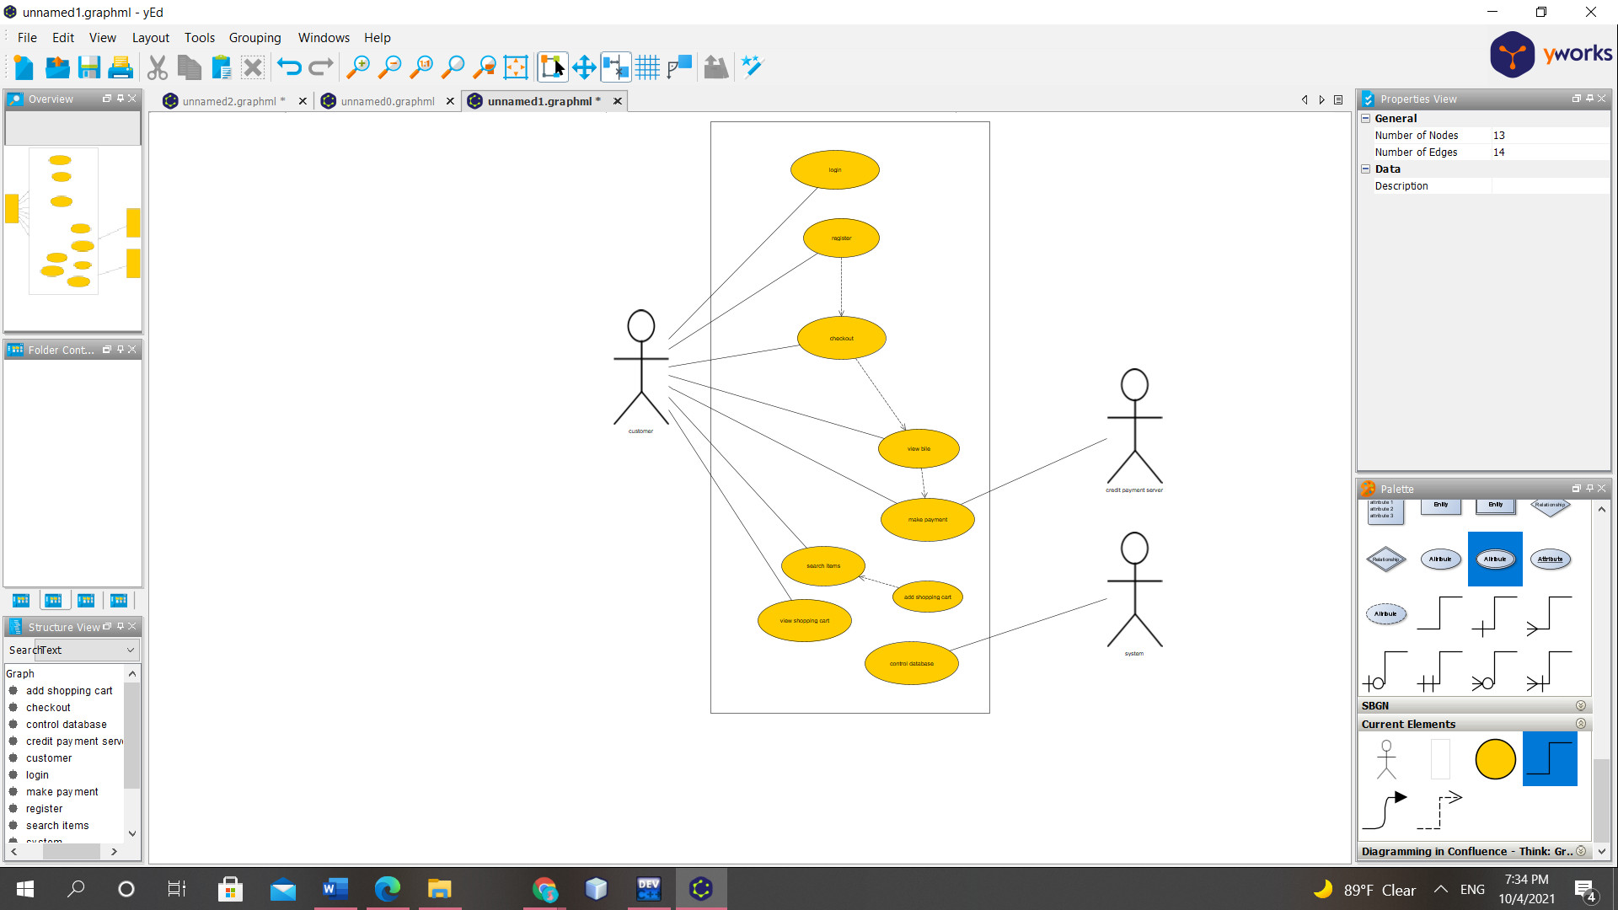

*Figure2*

*use case diagram*

## **Database Design**

Be your personal shopper online shopping system based on a shopping database that helps to keep system information safe. There are 5 entities in this system which are customer, product, shop cart, payment, and bill.

- Each customer has an unique username, password, email, address, country.

- Each product has a specific category, unique name, price, image.

- Each bill has an unique id, total price, and customer information which include customer username.

- Payment has customer username, total amount and card number.

- A shop cart has an unique order number , quantity ,total price, product name, price and customer username.

- Each customer can view the product, submit the order to the shop cart, checkout to pay for her/his order and view the bill.

- Products can be added to the shop cart.

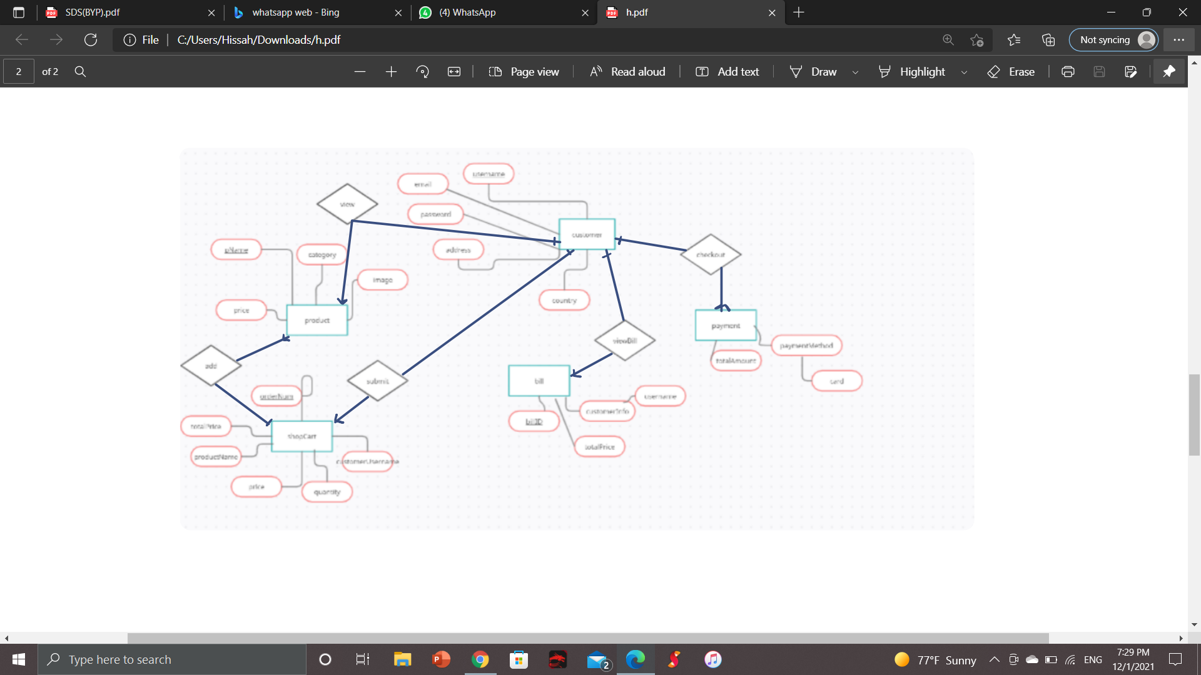

*Figure3*

entity relation diagram

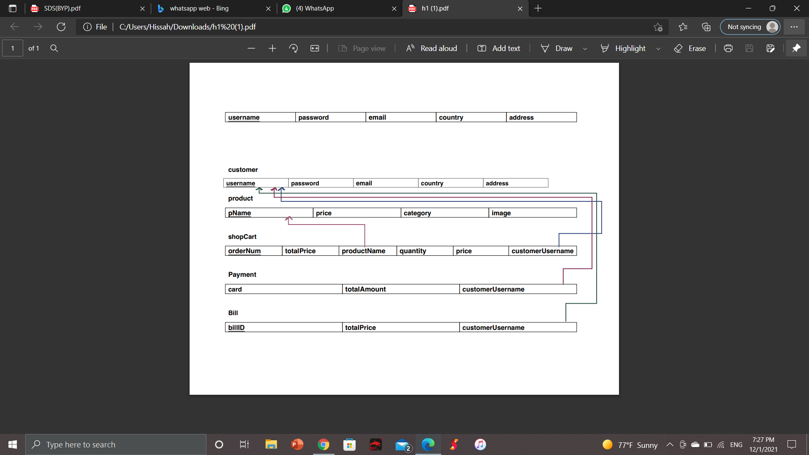

*Figure4*

*entity relation diagram mapping*

## **Hardware and Software Design**

## Software Design

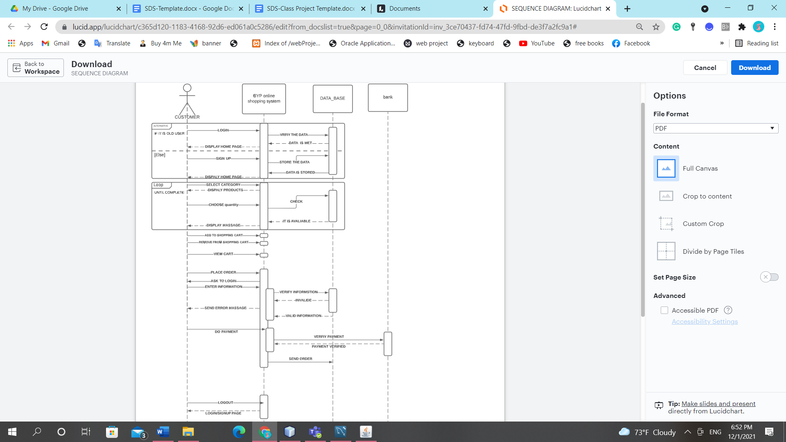

*Figure5*

here the sequence diagram for the user shows the customer who will interact with the system. there are BYP online shopping systems and databases and banks. the process the customers can log in to the system if the user is the old system the system will check the user information is stored in a database or not. if it is there , they can log in successfully and the system will display the homepage else the system will ask the user to sign up. after login and sign-up are done, the customer can select the category for the specified product such as the T-shirt category .then, the system will display the list of the products related to that category. the customer will be able to choose the quantity of the product. then, the system will check if there is enough quantity in the database and display a message to the user about all information of the product quantity and the process will repeat when the user asks about the quantity until the user completes the searching and specified the quantity. then, the user can view the shopping cart, add it to the shopping cart .then, if the user would like to place the order the system will inform the user that the payment is on the card. the system will check the user information by asking the user to log in if the user did not .the system will store the order in the database. then, the order will be placed. the user can log out. then, the system will display the login/sign-up page.

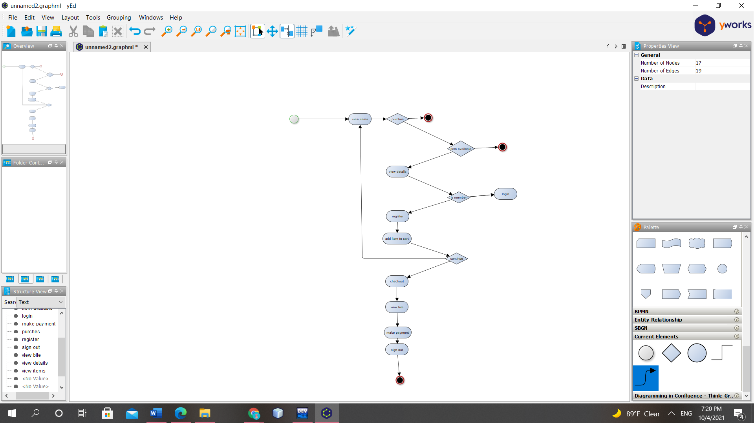

*Figure6*

the customer can view the items. if the items are available the system can view the details of the product. the system will check if the user is member or not. if it is a member ,the system will ask the user to login. if it is not a member, the system will ask the user to sign up. after login/sign up is done the user can add to shopping cart. if the user would like to add more items in shopping cart ,the user can again view the items . if the user is done viewing the products.He/She can go the checkout to view the bill. the payment will be on card. after all that the user can log out.

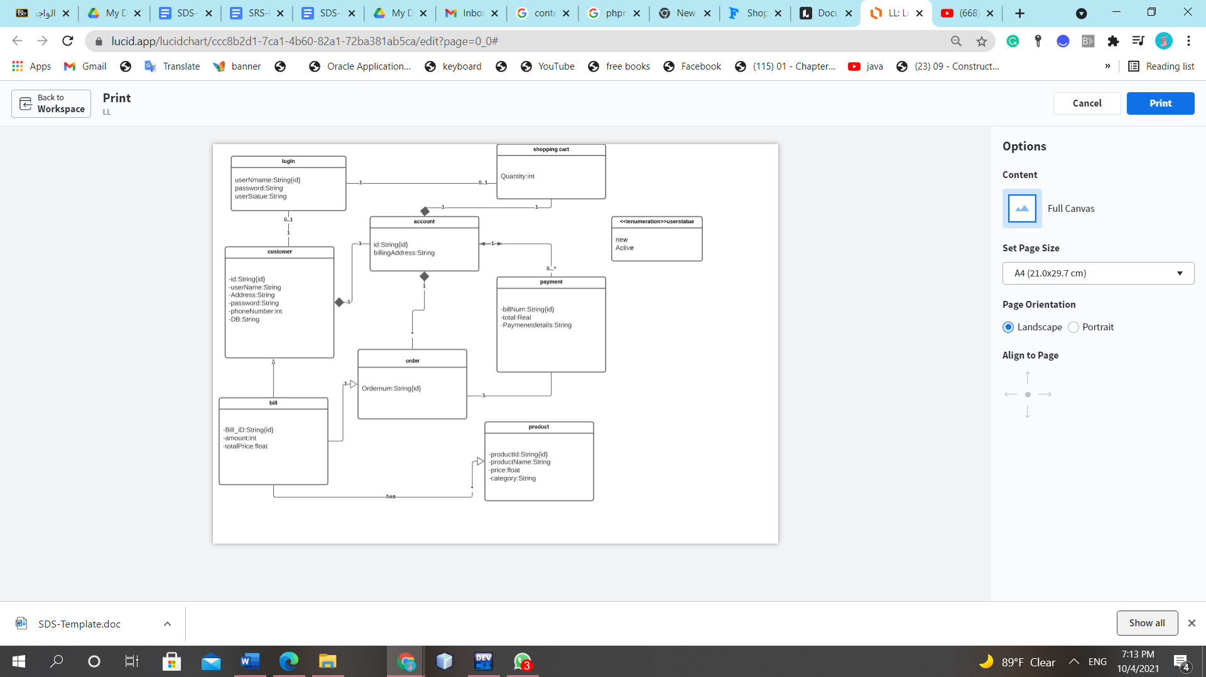

*Figure7*

## Hardware Design

not applicable.

## **Graphical User Interface Design**

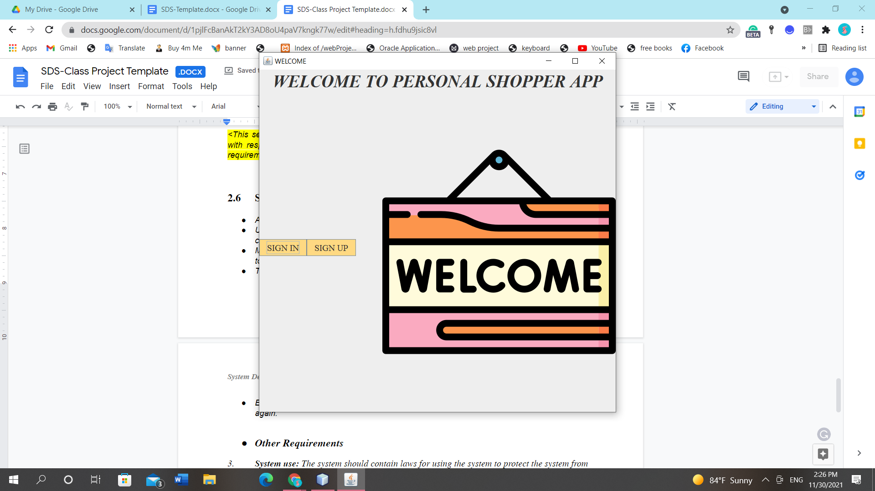

*Figure8*

*the first page which is a welcome page. It has two buttons sign in and signs up.*

*if the user click sign in, it will show the login page*

*if the user click sign up, it will show sign up*

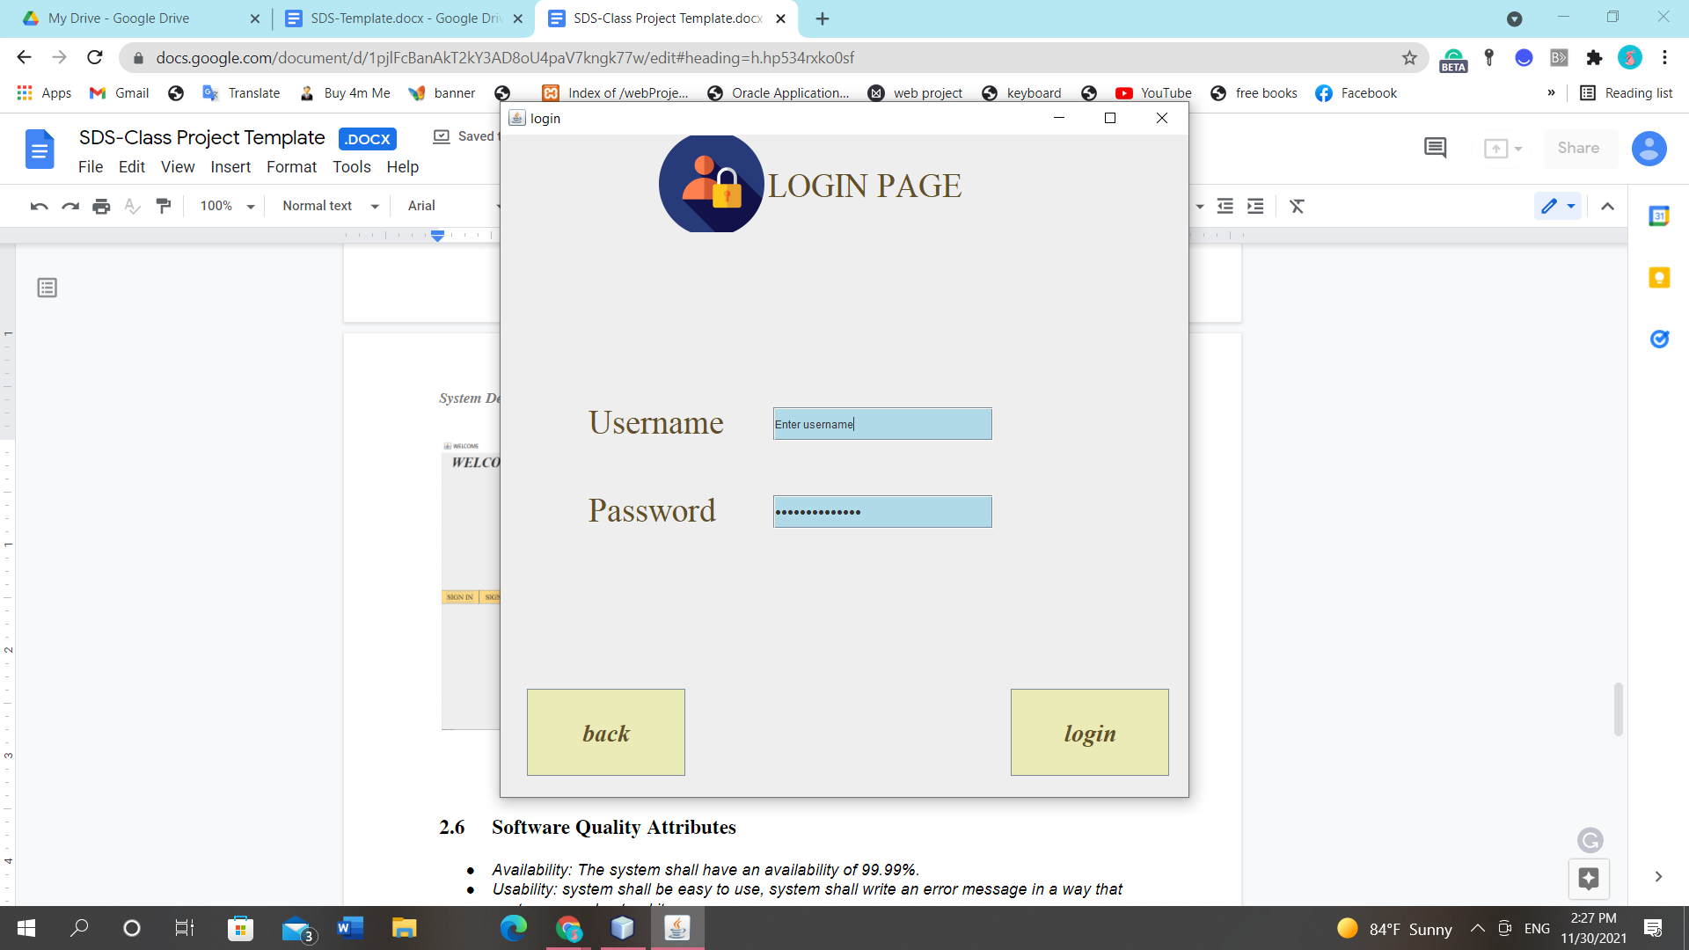

*Figure9*

*this is the login page. It asks the user to enter username and password*

*if the username and password are correct it will be a successful message. then, it will show the homepage when the user clicks login.*

*if the username and password are not correct it will show an unsuccessful message. then, it will not show a homepage when the user clicks login.*

*when the user clicks back, the system will go back to the welcome page*

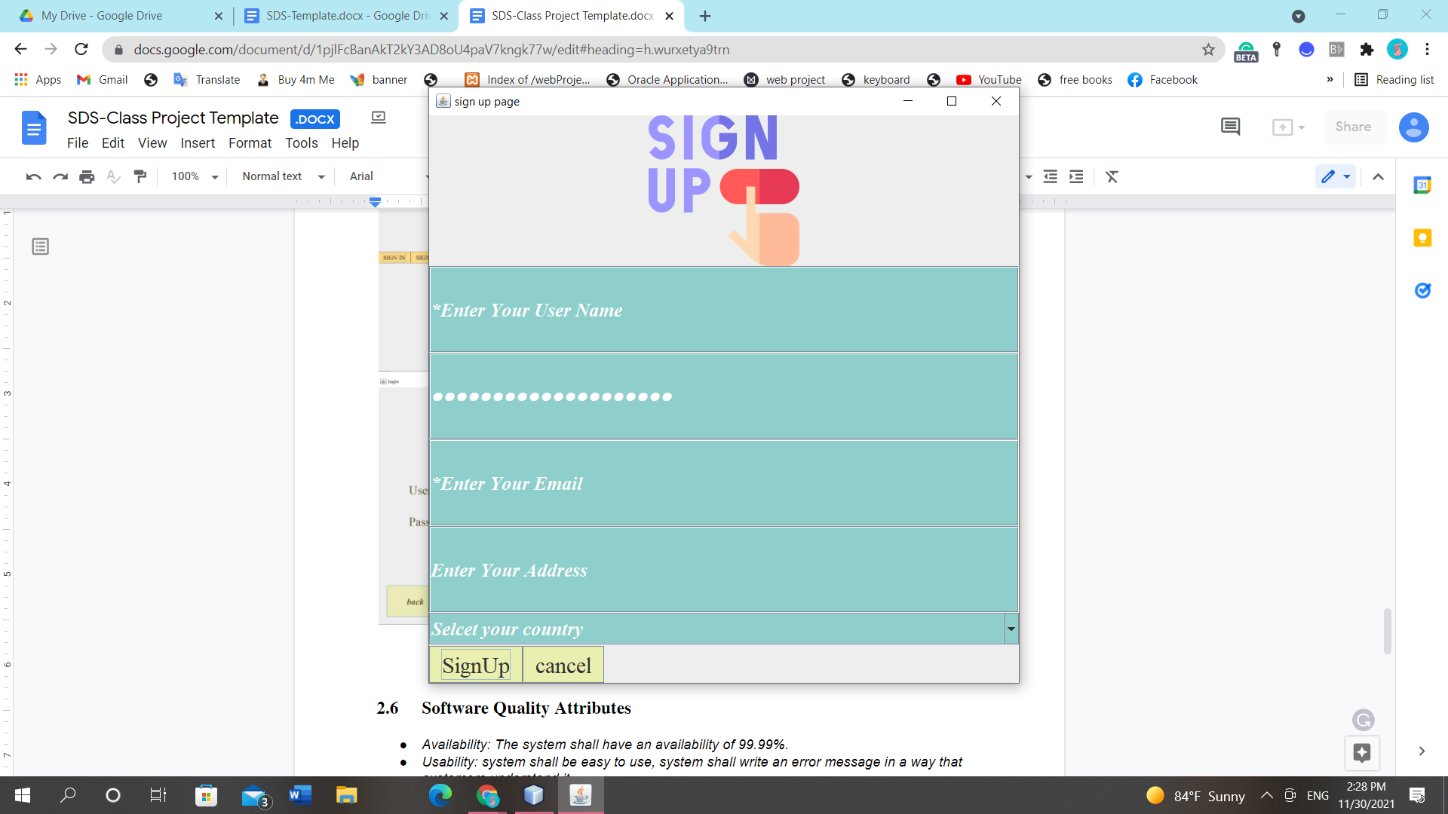

*Figure10*

*when the user clicks on the sign-up button, the system will show this page.*

*the user will enter all information in the field.*

*if the user click to sign up, the system will show the homepage*

*if the user click cancel, the sysem will show homepage*

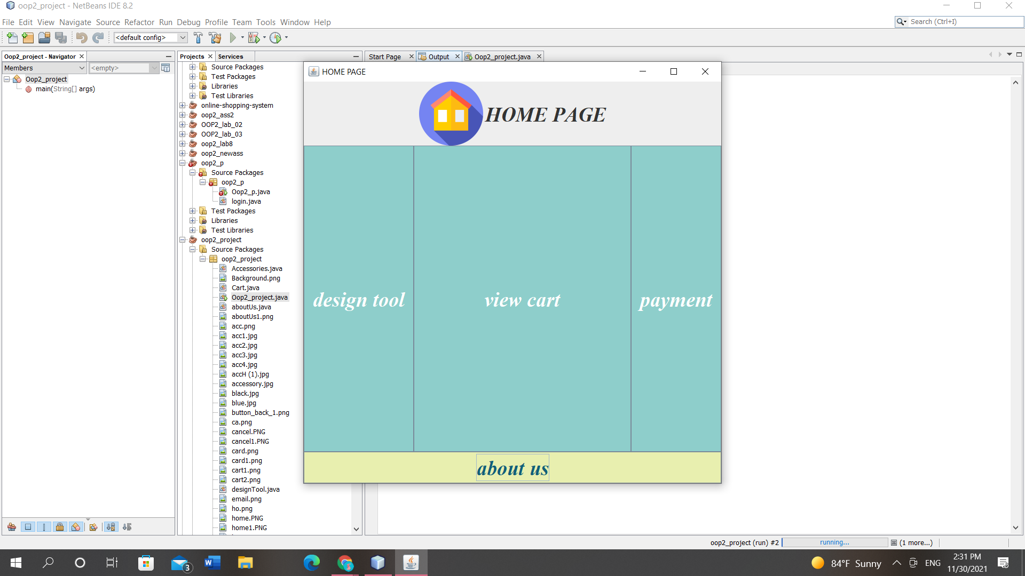

*Figure11*

*this the homepage which has 4 options*

*design tool*

*when the user clicks on the design too, the system will show a design tool that has 4 category t-shirt, shoes, jeans and accessories*

*view cart*

*it will show the cart content when the user click on view cart*

*payment*

*it will show the payment page when the user click on payment*

*about us*

*it will show the about us page when the click on it.*

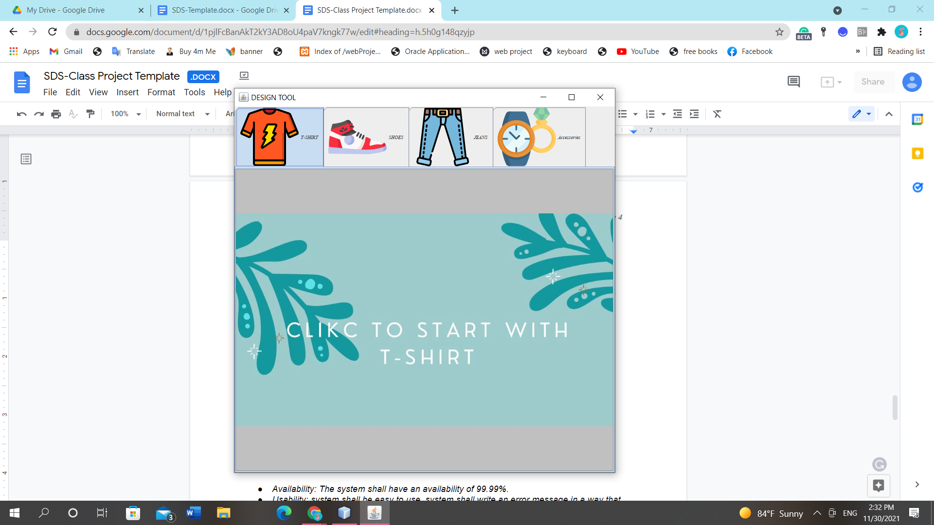

*Figure12*

*after clicking on the design tool button this page will appear.it is divided into 4 categories each of one has products.*

*when the user clicks on each category the system will show a page to click on it.*

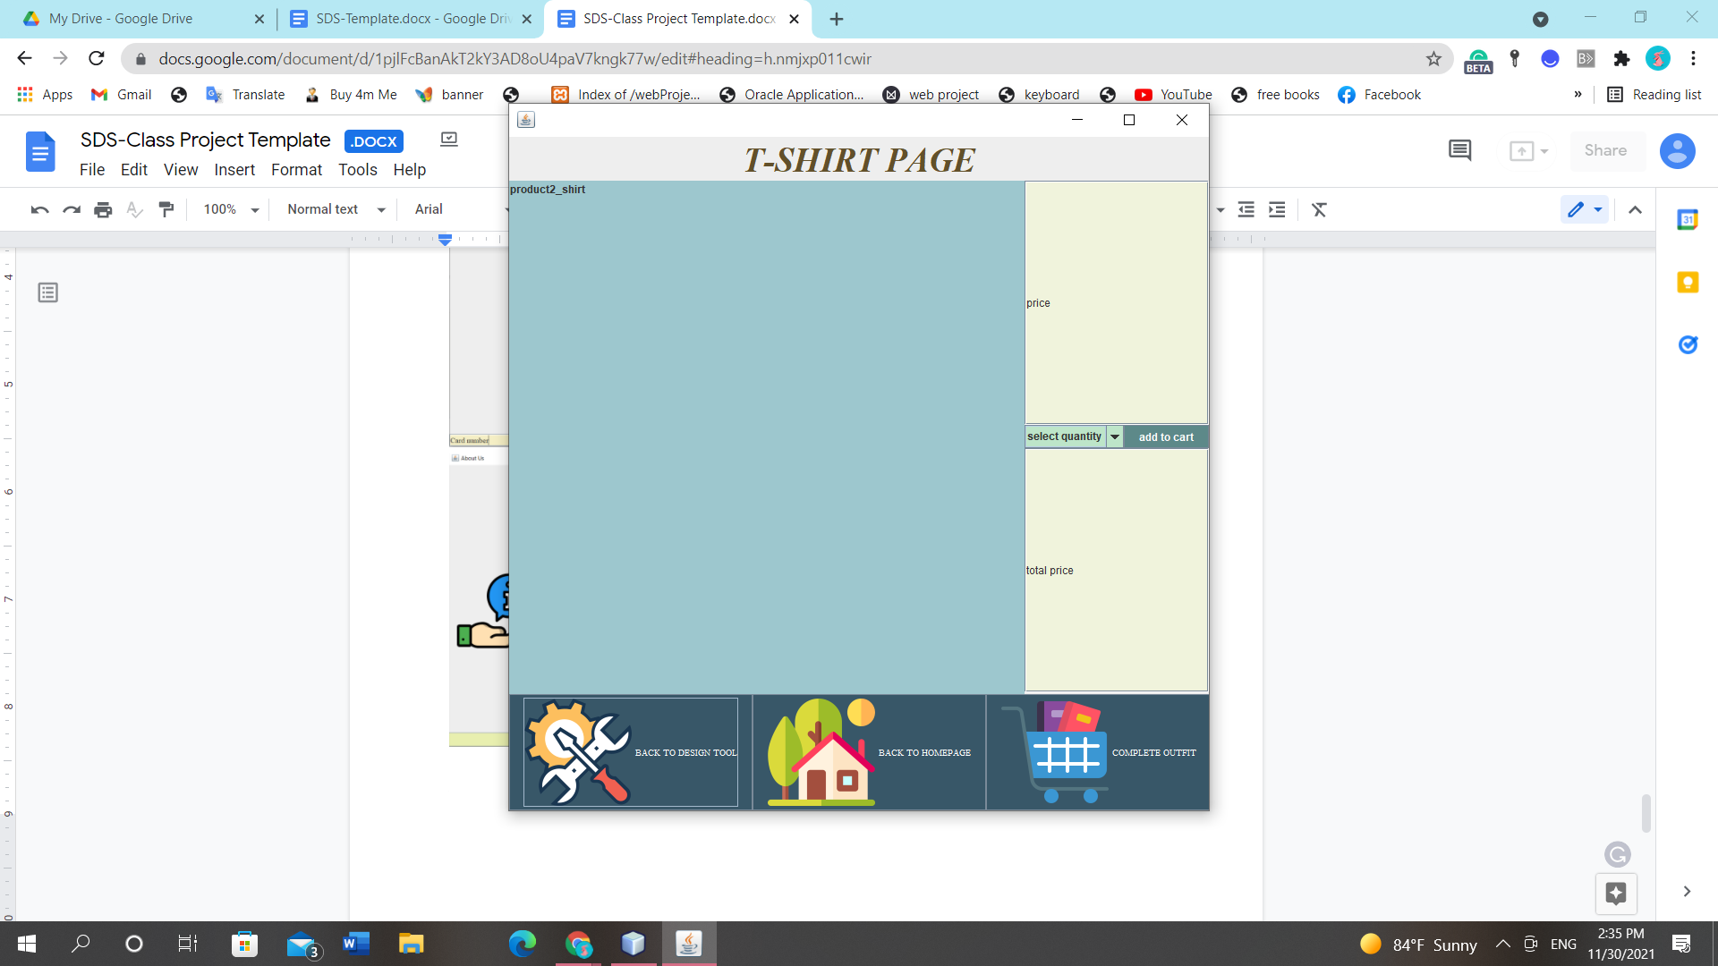

*Figure13*

*when the user clicks on a page in a specific category such as a t-shit page, the system will show this page.*

*the user can click on the product, the system will show the price and choose quantity and total price.*

*each product has an image*

*the below bar has 3 options*

*when the user clicks on the first button, the system will go back to the design tool.*

*when the user clicks on the second button, the system will go back to the homepage.*

*when the user clicks on the third button, the system will go to the next pagel.*

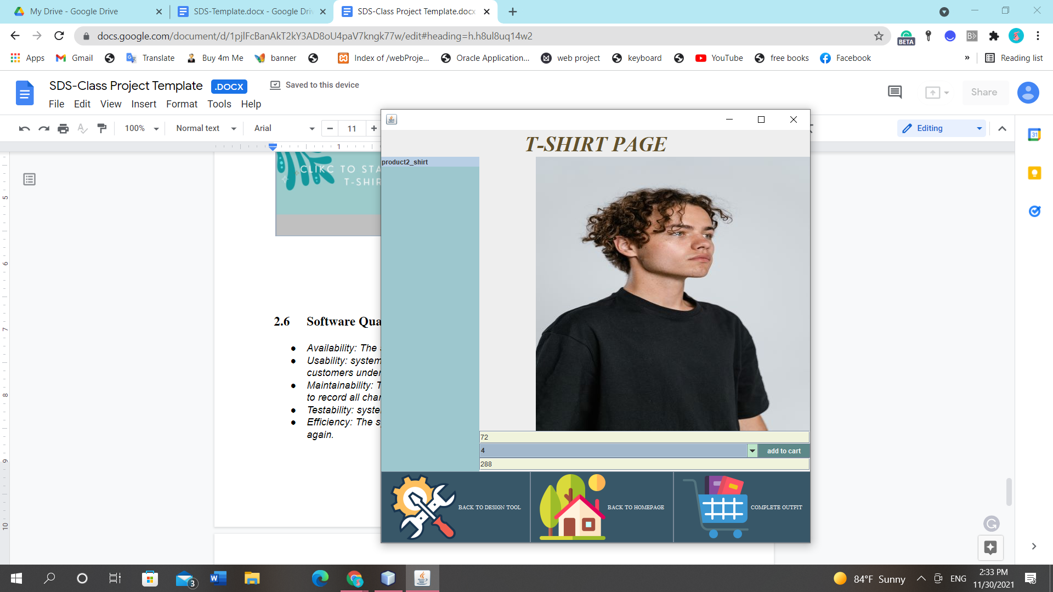

*Figure14*

*as we see when the user clicks on the product it shows all information about it.*

*after showing all information, the user can click on add to cart button.*

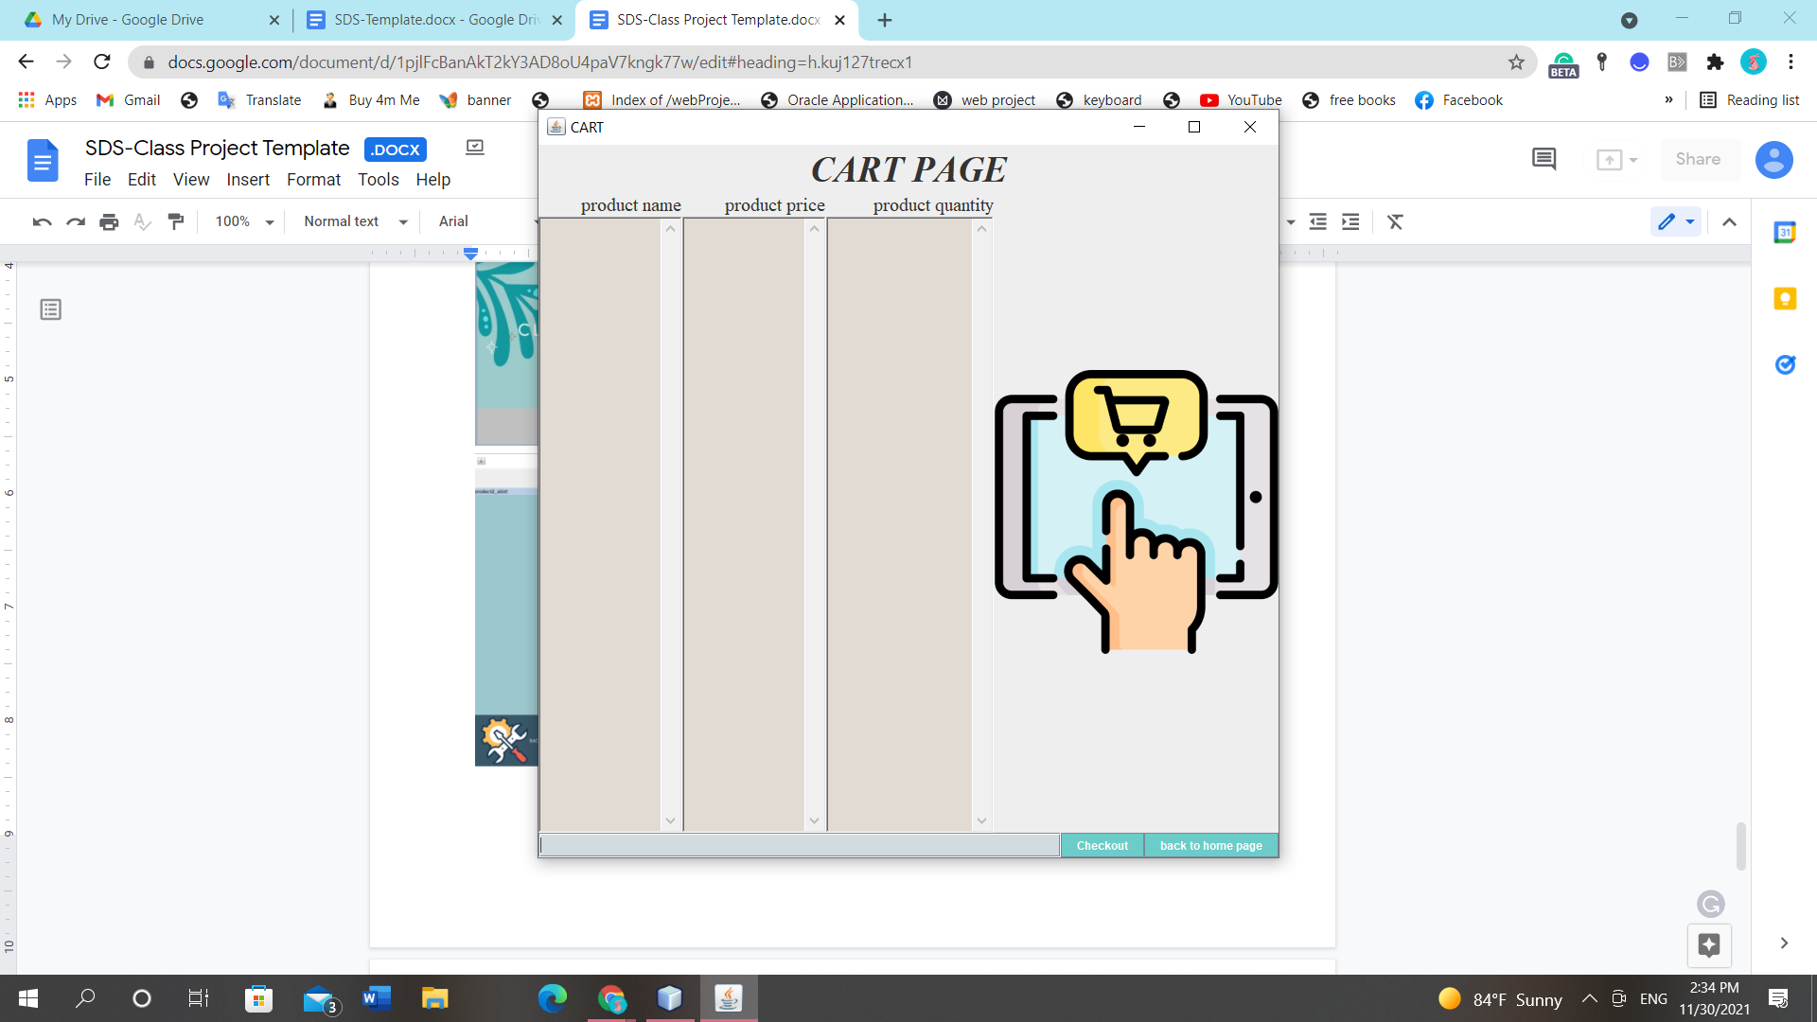

*Figure15*

*it will show all product information that is added by the user.*

*the user can also total the price. then,it can go to the checkout page*

*or go back to the homepage*

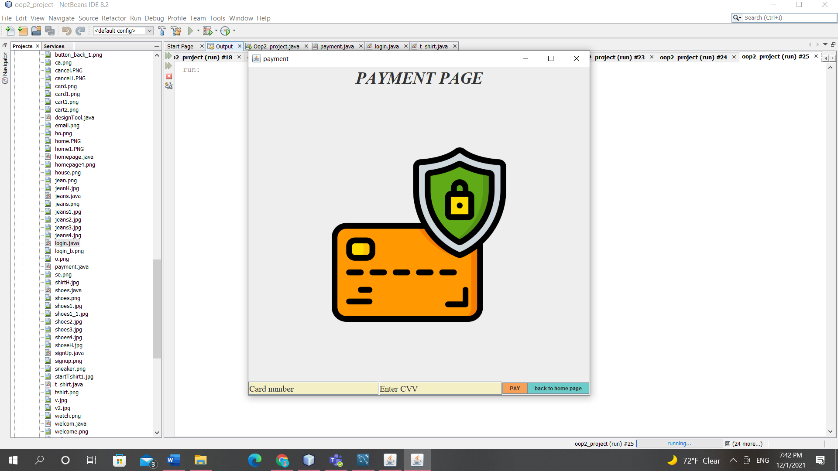

*Figure16*

*after selecting the product, the user can complete the purchase by paying.*

*this page asks the user to enter*

*the system will check if card number of length 16 and cvv of length 3*

*if it is correct it will display a successful message*

*if it is not correct it will display a unsuccessful message*

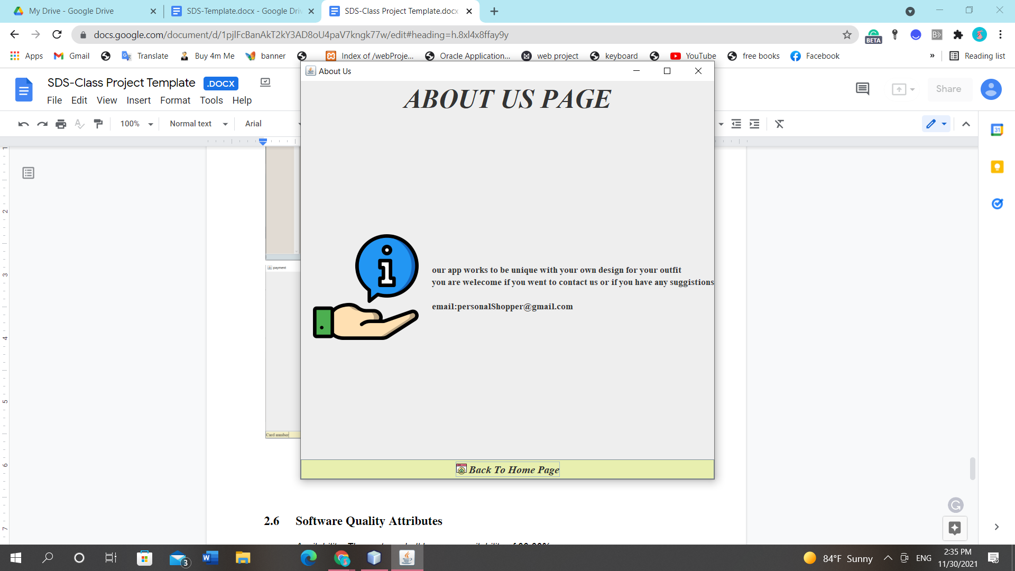

*Figure17*

*this the about us page which shows the information about shopping system*

## Software Quality Attributes

* *Availability: The system shall have availability of 99.99%.*
* *Usability: system shall be easy to use, system shall write an error message in a way that customers understand it.*
* *Maintainability: The system shall be easily updatable for fixes and patches and create files to record all changes, updates, fixes that happen on the system.*
* *Testability: system shall be able to run under any circumstance.*
* *Efficiency: The system shall validate the user id existence if it will prevent it from registering again.*

# *Other Requirements*

1. ***System use:*** *The system should contain laws for using the system to protect the system from any breaches or infringement of user privacy.*
2. ***Database:*** *The system should have a database to contain all information in the system such as product information, customer information and admins*

*information.*

**Appendix A: Glossary**

*Software Quality Attributes: The features that make the program high quality and efficient to achieve the best possible capabilities.*

*- User Interfaces: The interfaces or pages that are used by users and appear to them when using the system, and interact with them smoothly.*

*- Users: All people who have an interest in the system and who use the system.*

*- Owners: They are the owners of the system and those responsible for it.*

*- Customers: They are the stakeholders who can browse the program, add the products they want in the shopping cart, and specify the quantity of products required and purchased.*

*- Requirement: It is an expression of what the customer is asking for, meeting his needs, and aimins it.*

*- Netbeans: It is a program and an integrated development environment that uses the Java language.*

*My sql: it is a program that uses to create the database.*

**Appendix B: Detailed Analysis Models**

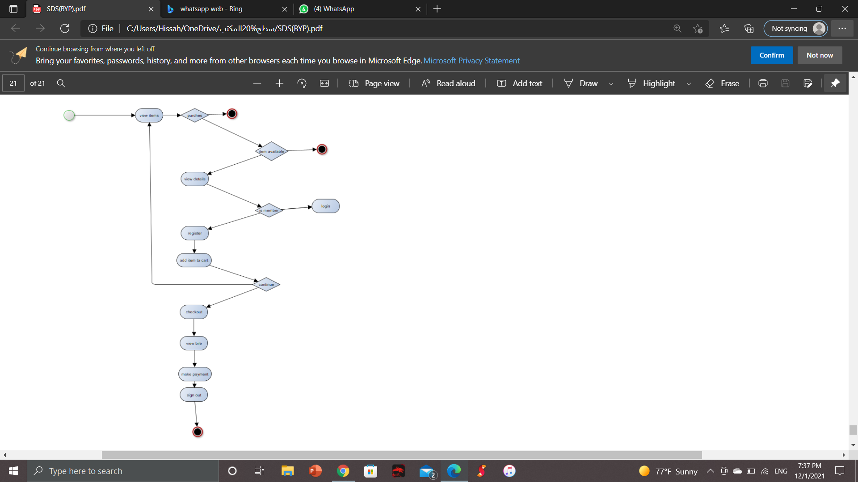

*Figure18*

**Appendix C: Issues List (If Any)**

* *Too many callings of customer inquiries may cause delays in responding to customer inquiries.*
* *The customer's lack of credibility in the request, so that when we prepare the order, he/she does not receive it, and it is a waste of our time and effort.*